Optimal exercise modality and dose to improve depressive symptoms in adults with major depressive disorder: A systematic review and Bayesian model-based network meta-analysis of RCTs
Table of Contents

Supplementary file 1: Search strategy 2
Supplementary file2. Characteristics of included studies 4
Supplementary file3. Risk of bias in the included studies 9
Supplementary file 4. Network meta- analysis supplementary Online Content 10
S4.1 Pairwise analysis 10
S4.1.1 Table S2. Assessment of inconsistency within comparisons 10
S4.1.2 Dot splitting method to explore inconsistency 10
S4.2 Comparison-adjusted funnel plot of all studies 11
S4.3 GRADE Assessment 12
S4.4 Effectiveness 13
4.4.1 Table 4. Intervention duration subgroup 13
S4.4.2 Table S5. Age subgroup 13
S4.5 Sensitivity analysis 13
Supplementary file5. Dose network meta- analysis supplementary Online Content 14
S5.1 Table S6. Dataset 14
S5.2 Select Model Fit 18
S5.2.1 Number of original studies at different dose scenarios 18
S5.2.2 Effect sizes of the original study in different types of training situations 19
S5.3 Key assumptions of Network Meta-Analysis 20
S5.3.1 Connectivity 20
S5.3.2 Consistency 21
S5.2.3 Transitivity 21
S5.4 Models’ selection 23
S5.4.1 Non-linear functions and models fit comparison 23
S5.4.2 Models selection 24
5.5 Ranking of effectiveness of interventions 27
Supplementary file6. PRISMA 28
REFERENCES 33

Supplementary file 1: Search strategy
Pubmed
((exercis*[Title/Abstract] OR aerobic*[Title/Abstract] OR running[Title/Abstract] OR jogging[Title/Abstract] OR walk*[Title/Abstract] OR hiking[Title/Abstract] OR swim*[Title/Abstract] OR aquatic*[Title/Abstract] OR cycling[Title/Abstract] OR bicycl*[Title/Abstract] OR strength*[Title/Abstract] OR activit*[Title/Abstract] OR fitness[Title/Abstract] OR train*[Title/Abstract] OR physical medicine[Title/Abstract] OR resistance[Title/Abstract] OR lift*[Title/Abstract]) OR yoga[Title/Abstract] OR tai chi[Title/Abstract] OR taiji[Title/Abstract] OR qigong[Title/Abstract] AND (depression[Title/Abstract] OR dysthymia[Title/Abstract])) AND (randomized controlled trial[Title/Abstract] OR clinical trial[Title/Abstract])

PsychINFO
S1 SU depression OR SU dysthymia OR SU depressive disorder
S2 SU randomized controlled trials OR SU clinical trial OR SU rct
S3 SU exercise OR SU aerobic OR SU running OR SU jogging OR SU walk OR SU hiking OR SU swim OR SU aquaSUc OR SU strength OR SU resistance OR SU yoga OR SU tai chi OR SU qigong
S4 (SU exercise OR SU aerobic OR SU running OR SU jogging OR SU walk OR SU hiking OR SU swim OR SU aquaSUc OR SU strength OR SU resistance OR SU yoga OR SU tai chi) AND (S1 AND S2 AND S3)

scopus
#1 (TITLE-ABS-KEY(exercise) OR TITLE-ABS-KEY(aerobic) OR TITLE-ABS-KEY(running) OR TITLE-ABS-KEY(Jogging) OR TITLE-ABS-KEY(Walk) OR TITLE-ABS-KEY(hiking) OR TITLE-ABS-KEY(Swim) OR TITLE-ABS-KEY(Aquatic) OR TITLE-ABS-KEY(Cycling) OR TITLE-ABS-KEY(Bicycl) OR TITLE-ABS-KEY(strength) OR TITLE-ABS-KEY(Activit) OR TITLE-ABS-KEY(fitness) OR TITLE-ABS-KEY(train) OR TITLE-ABS-KEY(physical medicine) OR TITLE-ABS-KEY(Resistance) OR TITLE-ABS-KEY(lift) OR TITLE-ABS-KEY(yoga) OR TITLE-ABS-KEY(Taiji) OR TITLE-ABS-KEY(tai chi) OR TITLE-ABS-KEY(qigong))
#2(TITLE-ABS-KEY(depression) OR TITLE-ABS-KEY(dysthymia))
#3(TITLE-ABS-KEY(randomized controlled trial) OR TITLE-ABS-KEY(clinical trial))
#4 #1 AND #2 AND #3

Embase
#1
'exercise'/exp OR exercise OR aerobic:ab,ti OR running:ab,ti OR jogging:ab,ti OR walk:ti OR hiking:ab,ti OR swim:ab,ti OR aquatic:ab,ti OR cycling:ab,ti OR bicycl:ab,ti OR strength:ab,ti OR activit:ab,ti OR fitness:ab,ti OR 'physical medicine':ab,ti OR resistance:ab,ti OR lift:ab,ti OR yoga:ab,ti OR taiji:ab,ti OR 'tai chi':ab,ti OR qigong:ab,ti
#2
'depression'/exp OR depression OR dysthymia:ab,ti
#3
'randomized controlled trial'/exp OR 'randomized controlled trial' OR 'clinical trial':ab,ti
#4
#1 AND #2 AND #3

SportDiscus
S1 TI depression OR TI dysthymia OR TI depressive disorder
S2 TI randomized controlled trials OR TI clinical trial OR TI RCT
S3 TI exercise OR TI aerobic OR TI running OR TI jogging OR TI walk OR TI hiking OR TI swim OR TI aquaTIc OR TI strength OR TI resistance OR TI yoga OR TI tai chi OR TI qigong
S4 S1 AND S2 AND S3
Web of science
#1 ((((((((((((((((((((TS=(exercise)) OR TS=(aerobic)) OR TS=(running)) OR TS=(jogging)) OR TS=(walk)) OR TS=( hiking)) OR TS=(swim)) OR TS=(aquatic)) OR TS=(cycling)) OR TS=(bicycl)) OR TS=(strength)) OR TS=(activit)) OR TS=(fitness)) OR TS=(train)) OR TS=(physical medicine)) OR TS=(resistance)) OR TS=(lift)) OR TS=(yoga)) OR TS=(tai chi)) OR TS=(taiji)) OR TS=(qigong)
#2 (TS=(randomized controlled trial)) OR TS=(clinical trial)
#3 (TS=(depression)) OR TS=(dysthymia)
#4 #1 AND #2 AND #3

Supplementary file2. Characteristics of included studies
Table S1. Characteristics of included studies

Author | Sample size(n) | Intervention M_{age} (SD) | Control M_{age} (SD) | Depression diagnosis | Intervention parameter | Intervention group condition | Control  group  condition | Outcome
Bieber,2021 (1) | 83 | 48.38±10.21 | 51.31±9.19 | DSM-IV; MDD | mind-body exercise | 12 weeks  3 days per week  90 min per session | Waiting-list control group | BDI
Blumenthal et al, 2007 (2) | 138 | 52.5±7.5 | 52.0±8.0 | DSM-IV; MDD | G1: Aerobic exercise  G2: home-based aerobic exercise | 16 weeks  3 days per week  45 min per session | Placebo | HAM-D
Brenes et al, 2007 (3) | 26 | 73.5±7.8 | 73.9±5.8 | DSM-IV  Depressive symptoms | Mixed exercise | 16 weeks  3 days per week  60 min per session | Usual care | HAM-D
Brush et al, 2020 (4) | 66 | 20.3± 2.8 | 20.3 ±2.8 | DSM-IV; MDD | Aerobic exercise | 8 weeks  3 days per week  45 min per session | stretching | BDI
Chau et al, 2020 (5) | 84 | NA | NA | DSM-IV; MDD | Mixed exercise | 12 weeks  3 days per week  60 min per session | Wait-list | HAM-D
Chin et al, 2004 (6) | 173 | 81.3±5.7 | 81.3 ± 4.4 | DSM-IV; MDD | G1: Aerobic exercise  G2: Resistance exercise  G3: Mixed exercise | 24 weeks  2 days per week  45-60 min per session | Placebo | GDS
Chou et al, 2004(7) | 14 | NA | NA | DSM-IV; MDD | Mind-body exercise | 12 weeks  3 days per week  45 min per session | Wait-list | CES-D
Danielsson et al, 2014 (8) | 32 | 44.7±12.5 | 46.3±13.9 | DSM-IV; MDD | Mixed exercise | 10 weeks  2 days per week  60 min per session | Wait-list | MADRS
Doose et al, 2015 (9) | 46 | 46.1 | 51.3 | DSM-IV; MDD | Aerobic exercise | 18weeks  3 days per week  60 min per session | Wait-list | HAM-D
Doyne et al, 1987 (10) | 40 | 28.6 | 29.5 | DSM-IV  Depressive symptoms | G1: Aerobic exercise  G2: Resistance exercise | 8 weeks  4 days per week  25 min per session | Wait-list | HAM-D
Epstein, 1986 (11) | 17 | 24-60 | 24-60 | DSM-IV; MDD | Aerobic exercise | 8 weeks  3 days per week  30 min per session | Wait-list | BDI
Gao et al, 2016 (12) | 50 | 54.5, NA | 53.5, NA | DSM-IV  Depressive symptoms | Aerobic exercise | 12 weeks  5 days per week  60-90 min per session | Usual care | SDS
Hallgren et al, 2015 (13) | 629 | 18-71 | 18-71 | DSM-IV  Depressive symptoms | Mixed exercise | 16 weeks  3 days per week  60 min per session | Usual care | MADRS
Hanssen et al, 2018 (14) | 34 | 37.8 ± 11.7 | NA | DSM-IV; MDD | G1: Aerobic exercise, HIIT, G2: Aerobic exercise, MICE | 4 weeks  3 days per week  35 min per session | NA | BDI
Haussleiter et al, 2020 (15) | 76 | 46.4 ± 11.6 | 46.4 ± 11.6 | DSM-IV; MDD | Mixed exercise | 6 weeks  3 days per week  50 min per session | Active comparison group | HAM-D
Hemat-Far et al, 2012 (16) | 20 | 18-25 | 18-25 | DSM-IV  Depressive  symptoms | Aerobic exercise | 8 weeks  3 days per week  40-60 min per session | Usual care | BDI
Huang et al, 2015 (17) | 39 | 76.4 | 75.9 | DSM-IV; MDD | Mixed exercise | 16 weeks  3 days per week  60 min per session | Usual care | GDS
Imboden et al, 2020 (18) | 42 | 41.3 ± 9.2 | 38.3 ± 13.4 | NA; MDD | Aerobic exercise | 6 weeks3  3 days per week  45 min per session | Active control group | HAM-D
Kinser et al, 2013 (19) | 27 | 40.9 ± 15.8 | 46.2 ±15.4 | Neuropsychiatric Interview (MINI) 6.0 depression module; MDD | Mind-body exercise | 8 weeks  1 days per week  75 min per session | Active control group | PHQ9
Kinser et al, 2014 (20) | 27 | 40.9 ± 15.8 | 46.2 ± 15.4 | Neuropsychiatric Interview (MINI) 6.0 depression module; MDD | Mind-body exercise | 8 weeks  1 days per week  75 m175in per session | Active control group | PHQ-9
Krogh et al,2012 (21) | 115 | 44.0 ± 11.9 | NA | DSM-IV  Depressive  symptoms | G1: Aerobic exercise, light intensity  G2: Aerobic exercise, moderate intensity | 12 weeks  3 days per week  45 min per session | NA | HAM-D
La Rocque et al, 2021 (22) | 53 | 34.5 ± 15.5 | 29.4 ± 13.1 | DSM-IV; MDD | G1: Aerobic exercise  G1: mind-body exercise | 8 weeks  2 days per week  G1:50-60 min, G2:90 min per session | Wait-list | HAM-D
Legrand et al, 2014 (23) | 44 | 21.6 ± 3.2 | 20.6 ± 2.2 | BDI  Depressive  symptoms | Aerobic exercise | 7 weeks  2 days per week  30 min per session | Wait-list | BDI
Lok et al, 2017 (24) | 80 | ≥65.0 | ≥65.00 | BDI  Depressive  symptoms | Aerobic exercise | 10 weeks  4 days per week  70 min per session | Wait-list | BDI
Makizako et al, 2019 (25) | 59 | 73.1 ± 5.3 | 73 ± 5.9 | GDS-15≥5;  Depressive  symptoms | Mixed exercise | 20 weeks  1 days per week  90 min per session | Health  education | GDS
Mather et al, 2002 (26) | 86 | 63.7 | 66.2 | GDS;  Depressive  symptoms | Mixed exercise | 10 weeks  2 days per week  55-65 min per session | Health  education | HRSD
Mota-Pereira et al, 2011 (27) | 29 | 45.3 ± 3.1 | 45.3 ± 3.1 | DSM-IV; MDD | Aerobic exercise | 6 weeks  5 days per week  30-45 min per session | Usual care | HAM-D
Nabkasorn et al, 2006 (28) | 59 | 18.7 ± 0.2 | 18.8 ± 0.1 | DSM-IV; MDD | Aerobic exercise | 8 weeks  5 days per week  50 min per session | Usual care | CES-D
Oertel-Knöchel et al, 2014 (29) | 16 | 36.6± 12.9 | 42.2 ± 8.3 | DSM-IV; MDD | Aerobic exercise | 4 weeks  3 days per week  75 min per session | Wait-list | BDI
Pilu et al, 2007 (30) | 30 | 40-60 | 40-60 | DSM-IV; MDD | Resistance exercise | 32 weeks  2 days per week  60 min per session | Usual care | HAM-D
Pfaff et al, 2014 (31) | 200 | 61.2 ± 7.7 | 60.7 ± 8.1 | DSM-IV; MDD | Mixed exercise | 12 weeks  8 days per week  30 min per session | Usual care | SIGMA
Prakhinkit et al, 2014 (32) | 45 | 74.8 ± 1.7 | 81.0 ± 1.7 | GDS  Depressive  symptoms | G1: Aerobic exercise  G2: Mind-body exercise | 12 weeks  3 days per week  20-30 min per session | Usual care | TGDS-30
Prathikanti et al,2017 (33) | 38 | 43.1 ± 15.2 | 43.8 ± 14.7 | BDI ; MDD | Mind-body exercise | 8 weeks  2 days per week  90 min per session | Attention control | BDI
Roy et al, 2018 (34) | 46 | 31.1 ± 8.9 | 32.9 ± 8.5 | HDRS−17; MDD | Aerobic exercise | 15 weeks  7 days per week  20 min per session | Usual care | HAM-D
Schuver et al, 2016 (35) | 40 | 42.7 ± 11.8 | NA | DSM-IV; MDD | G1: Aerobic exercise  G2: Mind-body exercise | 12 weeks  2 days per week  60 min per session | NA | BDI
Scott et al, 2019 (36) | 30 | 36.6 ± 12.8 | NA | DSM-IV; MDD | G1: Mind-body exercise  high dose  G2: Mind-body exercise  Low dose | 12 weeks  G1:3/90min classes＋4/30min homework sessions per week  G2: 2/90min classes＋3/30min homework sessions per week | NA | PHQ-9
Sharma et al, 2017 (37) | 25 | 39.4 ± 13.9 | 34.8 ± 13.6 | DSM-IV; MDD | mind-body exercise | 8 weeks  1 days per week  90 min per session | Wait-list | BDI
Singh et al, 1997 (38) | 32 | 70.0 ± 1.5 | 72.0 ± 2.0 | DSM-IV; MDD | Resistance exercise | 10 weeks  3 days per week  50 min per session | Health  education | HAM-D
Singh et al, 2005 (39) | 60 | 69.5 ± 6.0 | 69.0 ± 7.0 | DSM-IV; MDD | G1: Resistance exercise  High intensity  G2: Resistance exercise  Low intensity | 8 weeks  3 days per week  65 min per session | Usual care | HAM-D
Streeter et al,2017 (40) | 32 | 38.4 ± 15.1 | NA | DSM-IV; MDD | G1: Mind-body exercise  high dose  G2: Mind-body exercise  Low dose | 12 weeks  G1:3/90min classes＋4/30min homework sessions per week  G2: 2/90min classes＋3/30min homework sessions per week | NA | BDI
Streeter,2020 (41) | 28 | 37.1 ± 13.0 | NA | BDI; MDD | G1: Mind-body exercise  high dose  G2: Mind-body exercise  Low dose | 12 weeks  G1:3/90min classes＋4/30min homework sessions per week  G2: 2/90min classes＋3/30min homework sessions per week | NA | BDI
Tiffany Field, et al 2013 (42) | 75 | 24.4 ± 4.7 | 26.0 ± 5.6 | Structured Clinical Interview for Depression (SCID) MDD | mind-body exercise | 16 weeks  3 days per week  30-45 min per session | Wait-list | CES-D
Tsang et al. 2006 (43) | 82 | 82.1 ± 7.2 | 82.7 ± 6.8 | DSM-IV  Depressive  symptoms | mind-body exercise | 12 weeks  3 days per week  45 min per session | Attention control | GDS
Tsang et al. 2013 (44) | 38 | 79.7 ± 6.6 | 80.7 ± 4.4 | DSM-IV  Depressive  symptoms | mind-body exercise | 12 weeks  3 days per week  45 min per session | Attention control | GDS
Uebelacker,2017 (45) | 122 | 46.8 ± 12.3 | 46.2 ± 12.1 | DSM-IV; MDD | mind-body exercise | 10 weeks  2 days per week  80 min per session | Healthy Living Workshop (HLW) | QIDS
Yeung et al, 2012 (46) | 37 | 54±12 | 58±7 | HAM-D17; MDD | mind-body exercise | 12 weeks  2 days per week  60 min per session | Wait-list | HAM-D

Supplementary file3. Risk of bias in the included studies
Figure S1. Risk of bias in the included studies

Supplementary file 4. Network meta- analysis supplementary Online Content

S4.1 Pairwise analysis

S4.1.1 Table S2. Assessment of inconsistency within comparisons
Comparison | k | Direct | Indirect | Difference | z | P-value
AE vs MBE | 2 | -0.16 | -0.12 | -0.04 | -0.07 | 0.943
AE vs ME | 1 | -0.02 | -0.19 | 0.17 | 0.24 | 0.808
AE vs RE | 2 | 0.14 | -0.32 | 0.46 | 0.78 | 0.436
AE vs CON | 18 | -0.95 | -0.79 | -0.16 | -0.30 | 0.764
MBE vs ME | NA | NA | -0.04 | NA | NA | NA
MBE vs RE | NA | NA | -0.05 | NA | NA | NA
MBE vs CON | 13 | -0.83 | -0.56 | -0.27 | -0.41 | 0.682
ME vs RE | 1 | -0.02 | -0.01 | -0.01 | -0.02 | 0.985
ME vs CON | 9 | -0.72 | -1.61 | 0.88 | 0.89 | 0.374
RE vs CON | 8 | -0.70 | -1.34 | 0.64 | 0.79 | 0.429
I² represents the heterogeneity of pairwise comparisons; AE, Aerobic exercise; RE, resistance exercise; ME, mix exercise; MBE, mind-body exercise.

S4.1.2 Dot splitting method to explore inconsistency
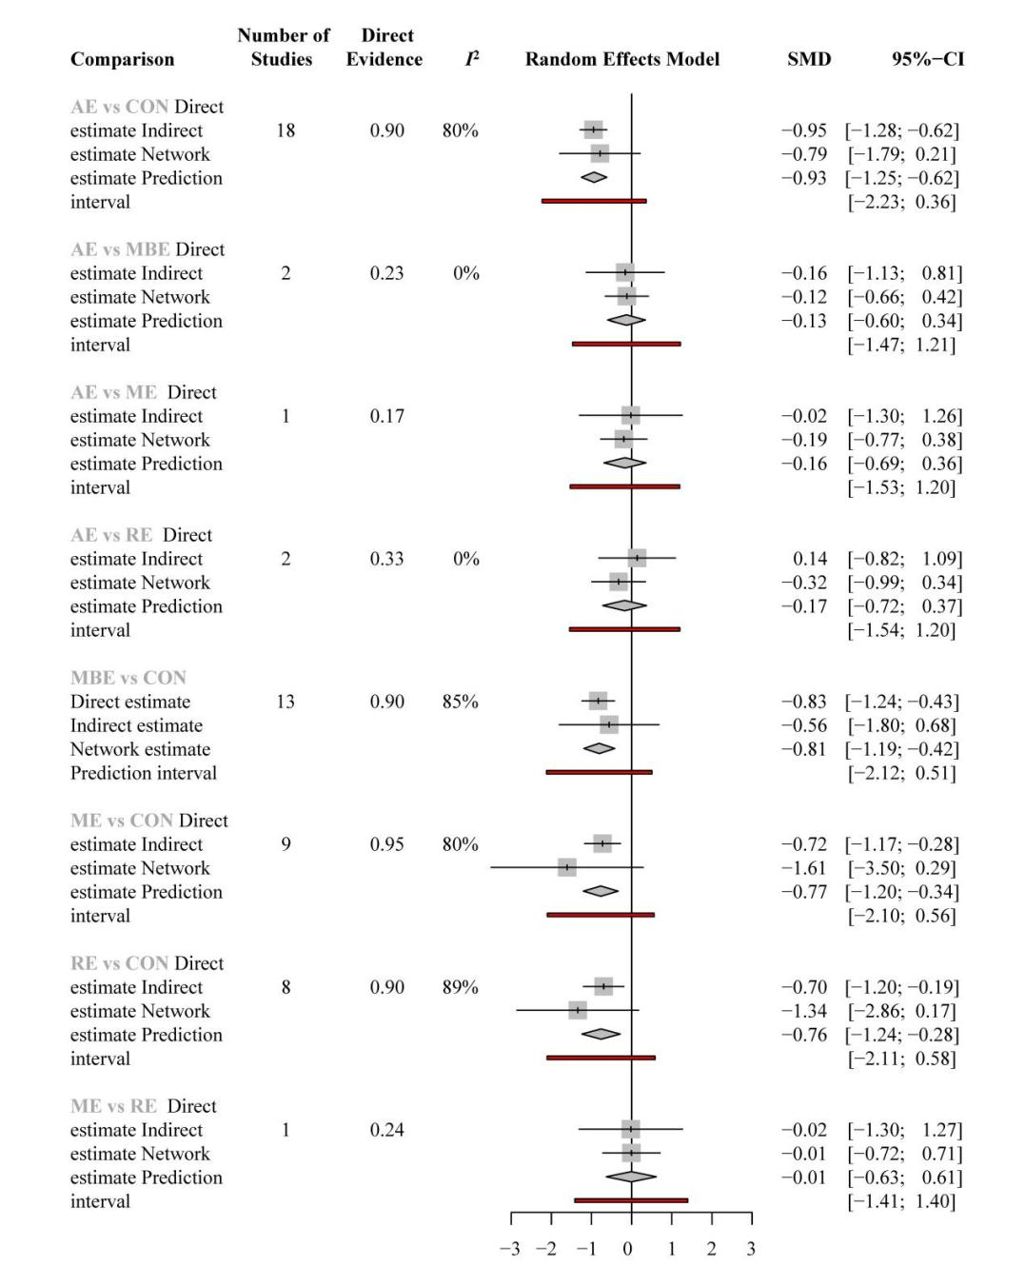
Figure S2. Dot splitting method to explore inconsistency. I² represents the heterogeneity of pairwise comparisons and the red region represents the prediction interval. AE, Aerobic exercise; RE, resistance exercise; ME, mix exercise; MBE, mind-body exercise.

S4.2 Comparison-adjusted funnel plot of all studies
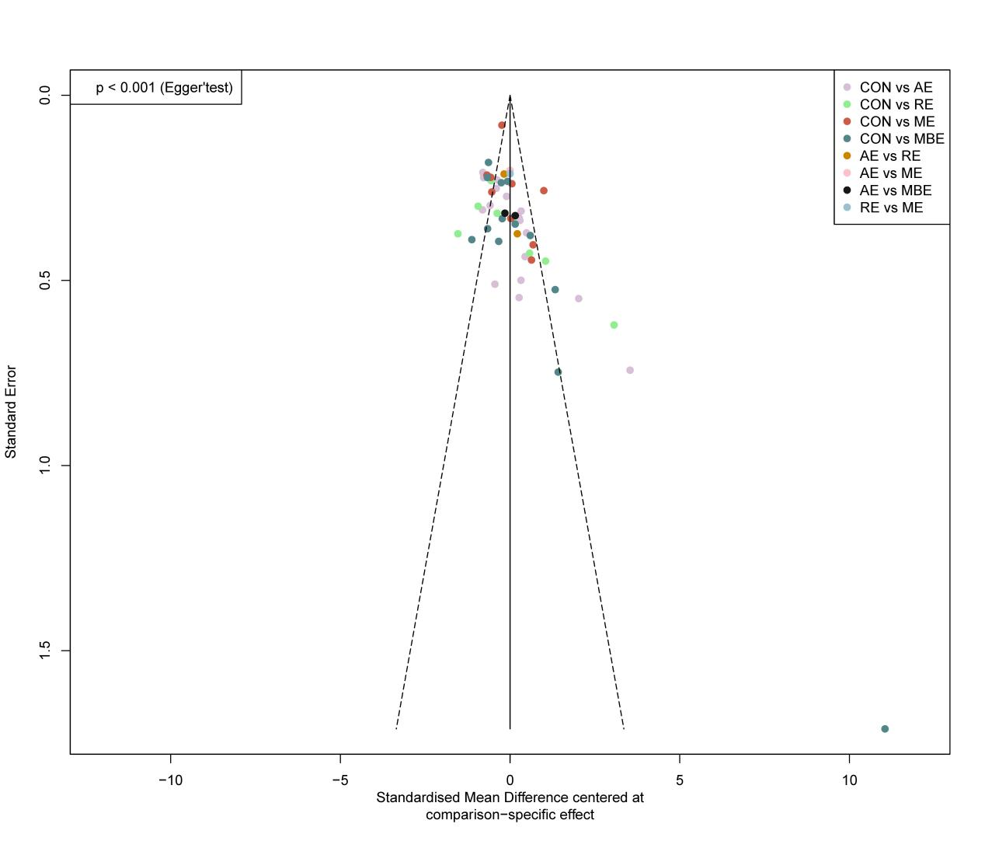
Figure S3. Comparison-adjusted funnel plot of all studies. AE, Aerobic exercise; RE, resistance exercise; ME, mix exercise; MBE, mind-body exercise.

S4.3 GRADE Assessment
Table S3. Details of GRADE assessment for all pairwise comparisons within the depression network.
Comparison | k | Direct SMD  [95% CI] | Quality of evidence | Indirect SMD  [95% CI] | Quality of evidence | Network SMD  [95% CI] | Quality of evidence | P-value
AE vs MBE | 2 | -0.16 (-1.13, 0.81) | Very low*‡ | -0.12 (-0.66, 0.42) | Low*† | -0.13 (-0.60, 0.34) | Low*† | 0.943
AE vs ME | 1 | -0.02 (-1.30, 1.26) | Very low*‡ | -0.19 (-0.77, 0.38) | Very low*‡ | -0.16 (-0.69, 0.36) | Very low*‡ | 0.808
AE vs RE | 2 | 0.14 (-0.82, 1.09) | Very low*‡ | -0.32 (-0.99, 0.34) | Very low*‡ | -0.17 (-0.72, 0.37) | Very low*‡ | 0.436
AE vs CON | 18 | -0.95 (-1.28, -0.62) | Moderate* | -0.79 (-1.79, 0.21) | Very low*‡ | -0.93 (-1.25, -0.62) | Moderate* | 0.764
MBE vs ME | 0 | NA |  | -0.04 (-0.61, 0.54) | Low*† | -0.04 (-0.61, 0.54) | Low*† | NA
MBE vs RE | 0 | NA |  | -0.05 (-0.65, 0.56) | Low*† | -0.05 (-0.65, 0.56) | Low*† | NA
MBE vs CON | 13 | -0.83 (-1.24, -0.43) | Low*† | -0.56 (-1.80, 0.68) | Very low*‡ | -0.81 (-1.19, -0.42) | Low*† | 0.682
ME vs RE | 1 | -0.02 (-1.30, 1.27) | Very low*‡ | -0.01 (-0.72, 0.71) | Low*† | -0.01 (-0.63, 0.61) | Low*† | 0.985
ME vs CON | 9 | -0.72 (-1.17, -0.28) | Moderate* | -1.61 (-3.50, 0.29) | Very low*‡ | -0.77 (-1.20, -0.34) | Moderate* | 0.374
RE vs CON | 8 | -0.7 (-1.20, -0.19) | Low*† | -1.34 (-2.86, 0.17) | Very low*‡ | -0.76 (-1.24, -0.28) | Low*† | 0.429

k = Number of studies providing direct evidence, prop = proportion of direct evidence, NMA (SMD) = estimated treatment effect (SMD) in network meta-analysis, direct (SMD) = estimated treatment effect (SMD) derived from direct evidence, indirect (SMD) = estimated treatment effect (SMD) derived from indirect evidence, p = p-value of test for disagreement (difference between direct and indirect evidence)
Reasons for downgrading: †Imprecision (1 downgrade), ‡Severe imprecision (2 downgrades), *risk of bias (1 downgrade)
The p-value indicated that the findings between direct and indirect comparisons was not statistically significant and therefore no comparisons have been downgraded based on inconsistency

S4.4 Effectiveness

4.4.1 Table 4. Intervention duration subgroup
AE | -0.68 (-1.42 to 0.06) | -0.17 (-0.84 to 0.50) | -0.26 (-0.92 to 0.39) | -0.92 (-1.45 to -0.39)
0.40 (-0.38 to 1.18) | RE | 0.52 (-0.19 to 1.22) | 0.42 (-0.33 to 1.17) | -0.24 (-0.82 to 0.35)
-0.30 (-1.18 to 0.58) | -0.70 (-1.76 to 0.36) | ME | -0.10 (-0.76 to 0.57) | -0.75 (-1.22 to -0.29)
-0.30 (-0.97 to 0.37) | -0.70 (-1.61 to 0.21) | 0.00 (-0.97 to 0.97) | MBE | -0.66 (-1.14 to -0.18)
-0.99 (-1.39 to -0.60) | -1.39 (-2.11 to -0.68) | -0.69 (-1.48 to 0.09) | -0.69 (-1.26 to -0.12) | CON
Results of the network meta-analysis for intervention durations less than 12 weeks are shown in blue, and results of the network meta-analysis for intervention durations greater than or equal to 12 weeks are shown in gray. AE, Aerobic exercise; RE, resistance exercise; ME, mix exercise; MBE, mind-body exercise; NA, not available.

S4.4.2 Table S5. Age subgroup
AE | 0.43 (-0.42 to 1.28) | 0.42 (-0.87 to 1.70) | -0.39 (-0.86 to 0.07) | -0.99 (-1.32 to -0.65)
-0.35 (-1.07 to 0.38) | RE | -0.01 (-1.50 to 1.48) | -0.82 (-1.72 to 0.09) | -1.41 (-2.24 to -0.58)
-0.19 (-0.86 to 0.48) | 0.16 (-0.50 to 0.81) | ME | -0.81 (-2.11 to 0.49) | -1.40 (-2.65 to -0.16)
-0.01 (-0.90 to 0.88) | 0.34 (-0.53 to 1.22) | 0.18 (-0.64 to 1.01) | MBE | -0.59 (-0.97 to -0.21)
-0.88 (-1.43 to -0.33) | -0.53 (-1.06 to 0.00) | -0.69 (-1.12 to -0.25) | -0.87 (-1.57 to -0.17) | CON
Results of the age greater than 50 network meta-analysis are shown in blue, and results of the age less than or equal to 50 network meta-analysis are shown in gray. AE, Aerobic exercise; RE, resistance exercise; ME, mix exercise; MBE, mind-body exercise; NA, not available.

S4.5 Sensitivity analysis
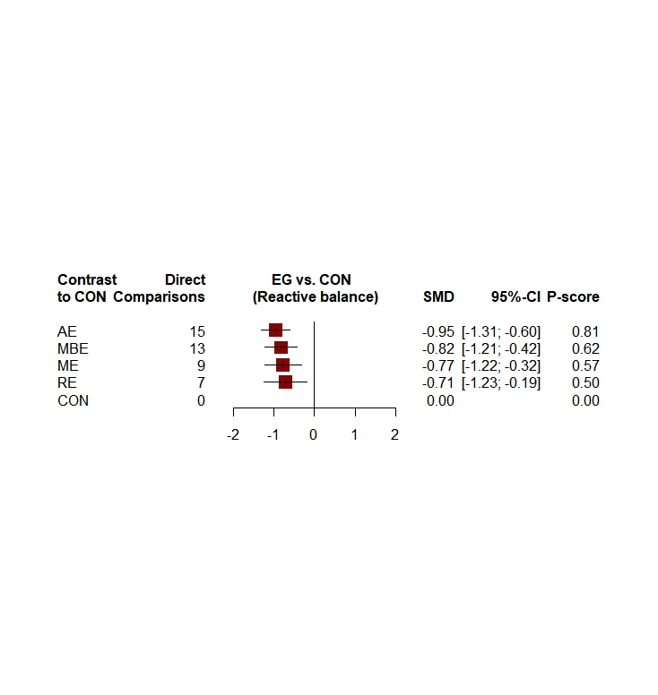

Figure S4. Forest plot of sensitivity analyses.

Supplementary file5. Dose network meta- analysis supplementary Online Content

S5.1 Table S6. Dataset
This supplementary file shows the datasets (i.e., at global exercise and agent levels) used in this study. The studyID indicates the name of the author and the year of publication. The y indicates the mean change from the baseline of the evaluation tool. The se indicates the standard error of the mean. The agent indicates the agent level. The Mets session indicates the energy expenditure in a session of the study. The exact_dose parameter indicates the exact estimated METs per week that participants accumulated in the study. The dose indicates the group of doses by approximation. The residual_dose indicates the difference between the exact dose and the dose allocated by approximation. The frequency is the number of days those participants were involved in physical activity. The min_day indicates how many minutes a session lasted. The N indicates the number of participants.
Study | Agent | Mets session | Exact dose | Dose | Residual dose | Frequency | Min/day | y | SE | N | Age | Length
Bieber,2021 | MBE | 297 | 891 | 900 | 9 | 3 | 90 | -7.8 | 1.7 | 47 | ≤50 | ≥12
Bieber,2021 | CON | 0 | 0 | 0 | 0 | 0 | 0 | -5.8 | 2.1 | 36 | ≤50 | ≥12
Blumenthal et al, 2007 | AE | 315 | 945 | 900 | 45 | 3 | 45 | -7.2 | 0.8 | 45 | ＞50 | ≥12
Blumenthal et al, 2007 | AE | 315 | 945 | 900 | 45 | 3 | 45 | -7.1 | 0.8 | 51 | ＞50 | ≥12
Blumenthal et al, 2007 | CON | 0 | 0 | 0 | 0 | 0 | 0 | -6.2 | 0.9 | 42 | ＞50 | ≥12
Brenes et al, 2007 | ME | 480 | 1440 | 1200 | 240 | 3 | 60 | -4.9 | 1.0 | 14 | ＞50 | ≥12
Brenes et al, 2007 | CON | 0 | 0 | 0 | 0 | 0 | 0 | 1.4 | 1.5 | 12 | ＞50 | ≥12
Brush et al, 2022 | AE | 337.5 | 1012.5 | 900 | 112.5 | 3 | 45 | -12.2 | 1.9 | 35 | ≤50 | ＜12
Brush et al, 2022 | CON | 0 | 0 | 0 | 0 | 0 | 0 | -6.4 | 1.8 | 31 | ≤50 | ＜12
Chau et al, 2020 | ME | 480 | 1440 | 1200 | 240 | 3 | 60 | -13.4 | 1.1 | 42 | N/A | ≥12
Chau et al, 2020 | CON | 0 | 0 | 0 | 0 | 0 | 0 | 0.0 | 1.2 | 42 | N/A | ≥12
Chin et al,2004 | RE | 250 | 500 | 600 | 100 | 2 | 45-60 | -5.7 | 0.9 | 41 | ＞50 | ≥12
Chin et al,2004 | ME | 262.5 | 525 | 600 | 75 | 2 | 45-60 | -5.8 | 0.7 | 49 | ＞50 | ≥12
Chin et al,2004 | AE | 275 | 550 | 600 | 50 | 2 | 45-60 | -5.9 | 0.7 | 48 | ＞50 | ≥12
Chin et al,2004 | CON | 0 | 0 | 0 | 0 | 0 | 0 | -5.0 | 0.8 | 35 | ＞50 | ≥12
Chou et al, 2004 | MBE | 135 | 405 | 300 | 105 | 3 | 45 | -16.7 | 3.7 | 7 | N/A | ≥12
Chou et al, 2004 | CON | 0 | 0 | 0 | 0 | 0 | 0 | 6.4 | 3.5 | 7 | N/A | ≥12
Danielsson et al, 2014 | ME | 480 | 960 | 900 | 60 | 2 | 60 | -10.3 | 0.8 | 18 | ≤50 | ＜12
Danielsson et al, 2014 | CON | 0 | 0 | 0 | 0 | 0 | 0 | -4.6 | 1.2 | 14 | ≤50 | ＜12
Doose et al, 2015 | AE | 480 | 1440 | 1200 | 240 | 3 | 60 | -9.5 | 1.1 | 30 | ≤50 | ＜12
Doose et al, 2015 | CON | 0 | 0 | 0 | 0 | 0 | 0 | -1.2 | 1.9 | 16 | ≤50 | ＜12
Doyne et al, 1987 | RE | 315 | 1260 | 1200 | 60 | 4 | 25 | -8.7 | 1.7 | 15 | ≤50 | ＜12
Doyne et al, 1987 | AE | 225 | 900 | 900 | 0 | 4 | 25 | -6.7 | 1.1 | 14 | ≤50 | ＜12
Doyne et al, 1987 | CON | 0 | 0 | 0 | 0 | 0 | 0 | 1.0 | 1.5 | 11 | ≤50 | ＜12
Epstein, 1986 | AE | 210 | 630 | 600 | 30 | 3 | 30 | -16.3 | 3.6 | 7 | ≤50 | ＜12
Epstein, 1986 | CON | 0 | 0 | 0 | 0 | 0 | 0 | -5.7 | 2.3 | 10 | ≤50 | ＜12
Gao et al, 2016 | AE | 450 | 2250 | 1200 | 1050 | 5 | 60-90 | -0.2 | 0.0 | 26 | ＞50 | ≥12
Gao et al, 2016 | CON | 0 | 0 | 0 | 0 | 0 | 0 | 0.0 | 0.0 | 24 | ＞50 | ≥12
Hallgren et al, 2015 | ME | 390 | 1170 | 1200 | 30 | 3 | 60 | -10.9 | 0.4 | 317 | ＞50 | ≥12
Hallgren et al, 2015 | CON | 0 | 0 | 0 | 0 | 0 | 0 | -7.1 | 0.5 | 312 | ＞50 | ≥12
Hanssen et al, 2018 | AE | 252 | 756 | 900 | 144 | 3 | 35 | -13.3 | 2.1 | 19 | ≤50 | ＜12
Hanssen et al, 2018 | AE | 168 | 504 | 600 | 96 | 3 | 35 | -11.2 | 2.1 | 15 | ≤50 | ＜12
Haussleiter et al, 2020 | ME | 200 | 600 | 600 | 0 | 3 | 50 | -13.0 | 0.9 | 36 | ＞50 | ＜12
Haussleiter et al, 2020 | CON | 0 | 0 | 0 | 0 | 0 | 0 | -8.3 | 1.0 | 40 | ＞50 | ＜12
Hemat-Far et al, 2012 | AE | 350 | 1050 | 900 | 150 | 3 | 40-60 | -8.4 | 2.0 | 10 | ≤50 | ＜12
Hemat-Far et al, 2012 | CON | 0 | 0 | 0 | 0 | 0 | 0 | -1.0 | 1.5 | 10 | ≤50 | ＜12
Huang et al, 2015 | ME | 225 | 675 | 600 | 75 | 3 | 60 | -4.0 | 0.7 | 19 | ＞50 | ≥12
Huang et al, 2015 | CON | 0 | 0 | 0 | 0 | 0 | 0 | -2.0 | 0.4 | 20 | ＞50 | ≥12
Imboden et al, 2020 | AE | 295.8 | 887.5 | 900 | 12.5 | 3 | 45 | -11.8 | 1.2 | 22 | ≤50 | ＜12
Imboden et al, 2020 | CON | 0 | 0 | 0 | 0 | 0 | 0 | -10.9 | 1.5 | 20 | ≤50 | ＜12
Kinser et al, 2013 | MBE | 187.5 | 187.5 | 300 | 112.5 | 1 | 75 | -8.2 | 2.5 | 15 | ≤50 | ＜12
Kinser et al, 2013 | CON | 0 | 0 | 0 | 0 | 0 | 0 | -3.4 | 2.6 | 12 | ≤50 | ＜12
Kinser et al, 2014 | MBE | 187.5 | 187.5 | 300 | 112.5 | 1 | 75 | 1.2 | 1.3 | 15 | ≤50 | ＜12
Kinser et al, 2014 | CON | 0 | 0 | 0 | 0 | 0 | 0 | -0.6 | 1.9 | 12 | ≤50 | ＜12
Krogh et al,2012 | AE | 225 | 675 | 600 | 75 | 3 | 45 | -7.9 | 0.8 | 56 | ≤50 | ≥12
Krogh et al,2012 | AE | 135 | 405 | 300 | 105 | 3 | 45 | -8.1 | 0.7 | 59 | ≤50 | ≥12
La Rocque et al, 2021 | AE | 385 | 770 | 900 | 130 | 2 | 50-60 | -5.3 | 1.2 | 20 | ≤50 | ＜12
La Rocque et al, 2021 | MBE | 225 | 450 | 600 | 150 | 2 | 90 | -5.2 | 1.3 | 18 | ≤50 | ＜12
La Rocque et al, 2021 | CON | 0 | 0 | 0 | 0 | 0 | 0 | 2.4 | 1.3 | 15 | ≤50 | ＜12
Legrand et al, 2014 | AE | 210 | 420 | 300 | 120 | 2 | 30 | -8.9 | 1.3 | 22 | ≤50 | ＜12
Legrand et al, 2014 | CON | 0 | 0 | 0 | 0 | 0 | 0 | 0.4 | 1.9 | 22 | ≤50 | ＜12
Lok et al, 2017 | AE | 245 | 980 | 900 | 80 | 4 | 70 | -5.6 | 1.1 | 40 | ＞50 | ＜12
Lok et al, 2017 | CON | 0 | 0 | 0 | 0 | 0 | 0 | -2.2 | 0.8 | 40 | ＞50 | ＜12
Makizako et al, 2019 | ME | 315 | 315 | 300 | 15 | 1 | 90 | -1.8 | 0.5 | 30 | ＞50 | ≥12
Makizako et al, 2019 | CON | 0 | 0 | 0 | 0 | 0 | 0 | -1.3 | 0.5 | 29 | ＞50 | ≥12
Mather et al, 2002 | ME | 160 | 480 | 600 | 120 | 3 | 60 | -4.1 | 1.5 | 43 | ＞50 | ＜12
Mather et al, 2002 | CON | 0 | 0 | 0 | 0 | 0 | 0 | -3.7 | 1.4 | 43 | ＞50 | ＜12
Mota-Pereira et al, 2011 | AE | 160 | 800 | 900 | 100 | 5 | 30-45 | -6.8 | 0.4 | 19 | ≤50 | ＜12
Mota-Pereira et al, 2011 | CON | 0 | 0 | 0 | 0 | 0 | 0 | 0.6 | 0.4 | 10 | ≤50 | ＜12
Nabkasorn et al, 2006 | AE | 225 | 1125 | 900 | 225 | 5 | 50 | -5.7 | 0.7 | 28 | ≤50 | ＜12
Nabkasorn et al, 2006 | CON | 0 | 0 | 0 | 0 | 0 | 0 | -1.3 | 1.1 | 31 | ≤50 | ＜12
Oertel-Knöchel et al,  2014 | AE | 450 | 1350 | 1200 | 150 | 3 | 75 | -7.5 | 3.5 | 8 | ≤50 | ＜12
Oertel-Knöchel et al,  2014 | CON | 0 | 0 | 0 | 0 | 0 | 0 | -1.5 | 4.4 | 8 | ≤50 | ＜12
Pilu,2007 | RE | 300 | 600 | 600 | 0 | 2 | 60 | -12.4 | 2.0 | 10 | NA | ≥12
Pilu,2007 | CON | 0 | 0 | 0 | 0 | 0 | 0 | -2.6 | 1.8 | 20 | NA | ≥12
Prakhinkit et al, 2014 | MBE | 53.3 | 160 | 300 | 140 | 3 | 20-30 | -8.2 | 0.2 | 15 | ＞50 | ≥12
Prakhinkit et al, 2014 | AE | 53.3 | 160 | 300 | 140 | 3 | 20-30 | -1.8 | 0.2 | 15 | ＞50 | ≥12
Prakhinkit et al, 2014 | CON | 0 | 0 | 0 | 0 | 0 | 0 | 0.7 | 0.2 | 15 | ＞50 | ≥12
Prathikanti et al,2017 | MBE | 225 | 450 | 600 | 150 | 2 | 90 | -9.5 | 2.8 | 20 | ≤50 | ＜12
Prathikanti et al,2017 | CON | 0 | 0 | 0 | 0 | 0 | 0 | -3.0 | 1.8 | 18 | ≤50 | ＜12
Roy et al, 2018 | AE | 100 | 700 | 600 | 100 | 7 | 20 | -4.3 | 1.0 | 23 | ≤50 | ＜12
Roy et al, 2018 | CON | 0 | 0 | 0 | 0 | 0 | 0 | -2.7 | 0.8 | 23 | ≤50 | ＜12
Schuver et al, 2016 | MBE | 138 | 276 | 300 | 24 | 2 | 60 | -8.1 | 2.1 | 20 | ≤50 | ≥12
Schuver et al, 2016 | AE | 150 | 300 | 300 | 0 | 2 | 60 | -10.8 | 1.6 | 20 | ≤50 | ≥12
Scott et al, 2019 | MBE | 325 | 975 | 900 | 75 | 3 | 90 | -7.0 | 0.9 | 15 | ≤50 | ≥12
Scott et al, 2019 | MBE | 337.5 | 675 | 600 | 75 | 2 | 90 | -5.5 | 1.1 | 15 | ≤50 | ≥12
Sharma et al, 2017 | MBE | 207 | 207 | 300 | 93 | 1 | 90 | -20.4 | 2.3 | 13 | ≤50 | ＜12
Sharma et al, 2017 | CON | 0 | 0 | 0 | 0 | 0 | 0 | -1.8 | 2.4 | 12 | ≤50 | ＜12
Singh et al, 1997 | RE | 250 | 750 | 900 | 150 | 3 | 50 | -7.0 | 0.3 | 17 | ＞50 | ＜12
Singh et al, 1997 | CON | 0 | 0 | 0 | 0 | 0 | 0 | -2.5 | 0.3 | 15 | ＞50 | ＜12
Singh et al, 2005 | RE | 325 | 975 | 900 | 75 | 3 | 65 | -9.5 | 1.1 | 20 | ＞50 | ＜12
Singh et al, 2005 | RE | 195 | 585 | 600 | 15 | 3 | 65 | -7.1 | 1.3 | 20 | ＞50 | ＜12
Singh et al, 2005 | CON | 0 | 0 | 0 | 0 | 0 | 0 | -5.3 | 1.2 | 20 | ＞50 | ＜12
Streeter et al,2017 | MBE | 429 | 1287 | 1200 | 87 | 3 | 90 | -18.6 | 1.5 | 16 | ≤50 | ≥12
Streeter et al,2017 | MBE | 445.5 | 891 | 900 | 9 | 2 | 90 | -17.6 | 2.0 | 16 | ≤50 | ≥12
Tiffany Field, 2013 | MBE | 20 | 60 | 300 | 240 | 3 | 30-45 | -8.9 | 1.6 | 37 | ≤50 | ≥12
Streeter, 2020 | MBE | 325 | 975 | 900 | 75 | 3 | 90 | -19.5 | 1.8 | 13 | ≤50 | ≥12
Streeter, 2020 | MBE | 337.5 | 675 | 600 | 75 | 2 | 90 | -17.5 | 2.4 | 15 | ≤50 | ≥12
Tiffany Field, 2013 | CON | 0 | 0 | 0 | 0 | 0 | 0 | -2.8 | 1.8 | 38 | ≤50 | ≥12
Tsang et al. 2006 | MBE | 120 | 360 | 300 | 60 | 3 | 45 | -2.0 | 0.4 | 48 | ＞50 | ≥12
Tsang et al. 2006 | CON | 0 | 0 | 0 | 0 | 0 | 0 | -0.4 | 0.2 | 34 | ＞50 | ≥12
Tsang et al. 2013 | MBE | 150 | 450 | 600 | 150 | 3 | 45 | -2.2 | 0.8 | 21 | ＞50 | ≥12
Tsang et al. 2013 | CON | 0 | 0 | 0 | 0 | 0 | 0 | 1.6 | 0.9 | 17 | ＞50 | ≥12
Uebelacker,2017 | MBE | 200 | 400 | 300 | 100 | 2 | 80 | -3.9 | 0.4 | 63 | ≤50 | ＜12
Uebelacker,2017 | CON | 0 | 0 | 0 | 0 | 0 | 0 | -3.2 | 0.6 | 59 | ≤50 | ＜12
Yeung et al, 2012 | MBE | 180 | 360 | 300 | 60 | 2 | 60 | -12.8 | 0.9 | 26 | ＞50 | ≥12
Yeung et al, 2012 | CON | 0 | 0 | 0 | 0 | 0 | 0 | -12.5 | 0.8 | 11 | ＞50 | ≥12

S5.2 Select Model Fit

S5.2.1 Number of original studies at different dose scenarios
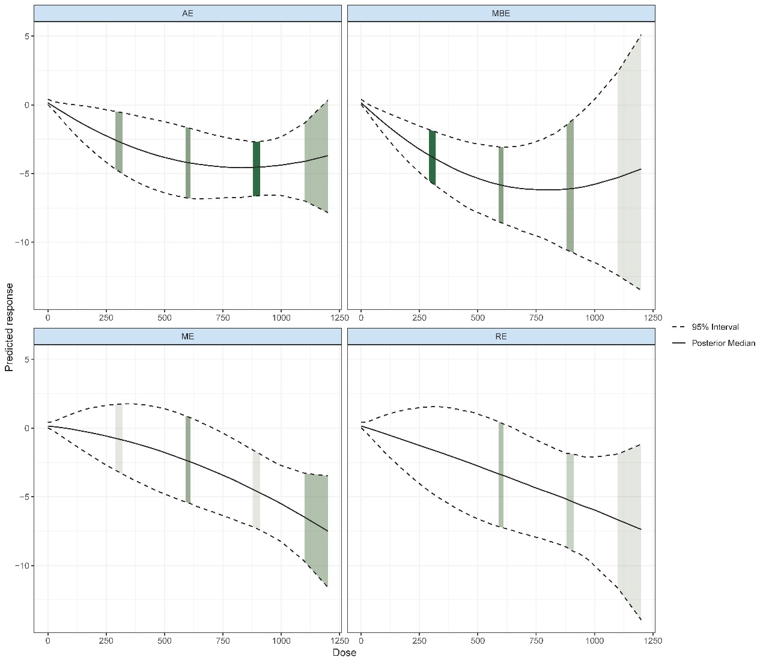
Figure S5. Number of original studies at different dose scenarios. AE, Aerobic exercise; RE, resistance exercise; ME, mix exercise; MBE, mind-body exercise.

S5.2.2 Effect sizes of the original study in different types of training situations
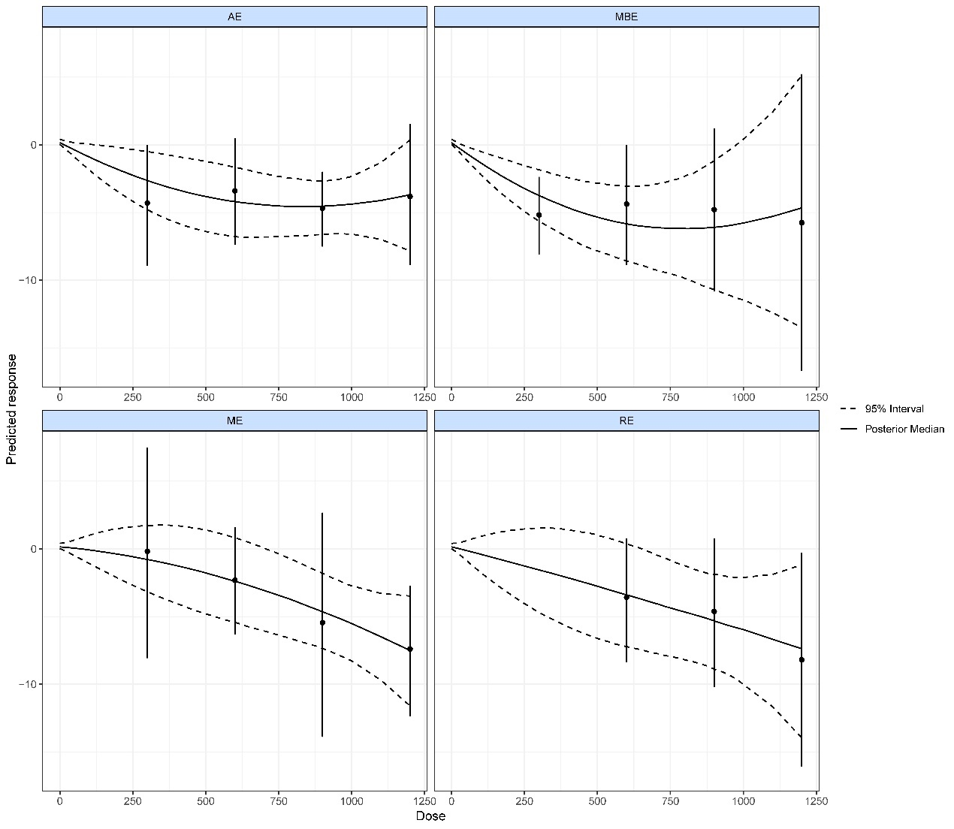
Figure S6. Effect sizes of the original study in different types of training situations. AE, Aerobic exercise; RE, resistance exercise; ME, mix exercise; MBE, mind-body exercise.

S5.3 Key assumptions of Network Meta-Analysis
The following are the three key assumptions of the network meta-analysis.

S5.3.1 Connectivity
Connectivity is a key assumption in NMA that, if considered insufficient (i.e., due to lack of direct comparisons), may lead to low statistical power and misleading results. Our study assessed network connectivity at the motor and dose levels and did not find any evidence of network unconnectedness (Figure S1 and Figure S2).
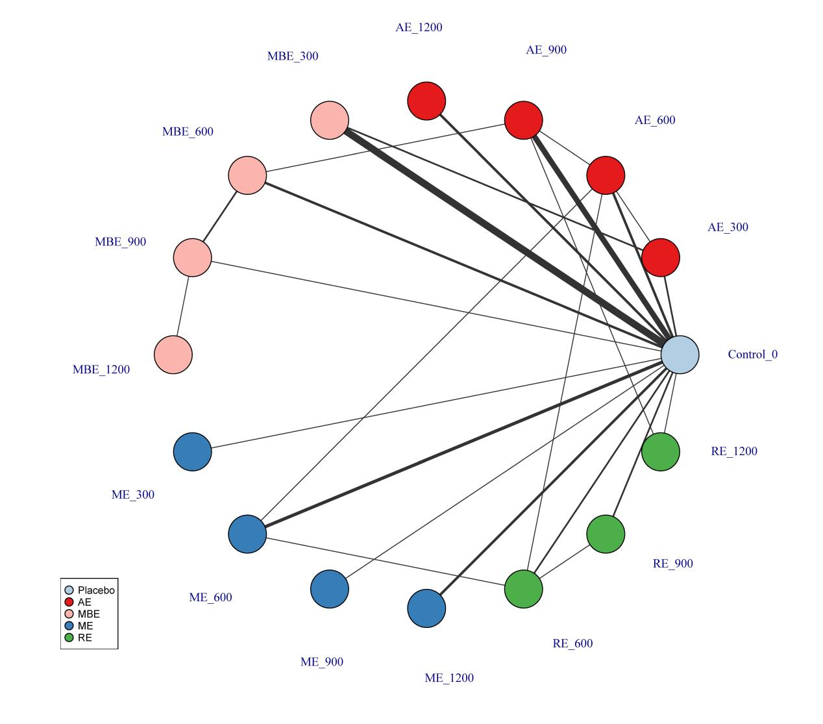
Figure S7. Treatment-level network. The first value indicates the specific intervention and the second one is the corresponding dose of that intervention. AE, Aerobic exercise; RE, resistance exercise; ME, mix exercise; MBE, mind-body exercise.
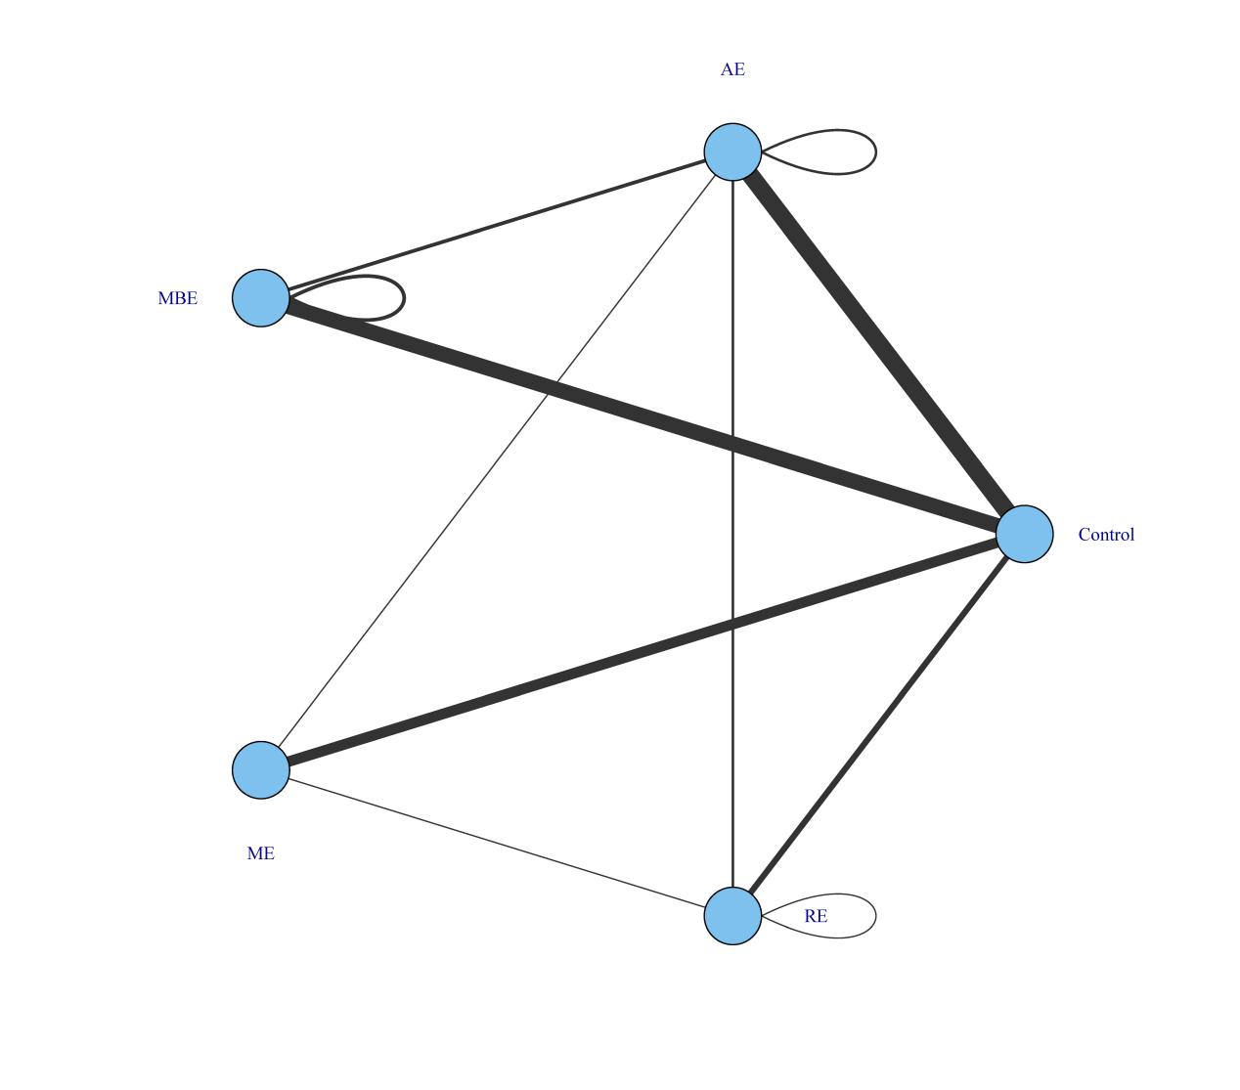
Figure S8. Agent-level network. AE, Aerobic exercise; RE, resistance exercise; ME, mix exercise; MBE, mind-body exercise.

S5.3.2 Consistency
We performed a consistency analysis of the data by comparing the consistency of the network (i.e., network effect size) with the unrelated mean effects (UME) model (i.e., pairwise effect sizes). In practice, we checked whether the bias, the number of estimated parameters in the network, and the Deviance Information Criterion (DIC) metric were similar for both models, indicating a good fit (47). The comparison of these parameters showed a good agreement between the different models (Table S1).
Table S7. Consistent and UME models fit comparison
Model | pD | Deviance | Residual deviance | DIC
Consistent | 88.70 | 257.49 | 90.07 | 345.30
UME | 88.90 | 257.53 | 90.10 | 345.50
Note. pD: Number of estimated parameters; DIC: Deviance Informative Criterion; SD: Standard
Deviation; UME: Unrelated Mean Effects. Scientific literature indicated that the main indicator to
assess the model fit is the DIC. As lower DIC, better fit.

S5.2.3 Transitivity
NMAs are based on the assumption of indirect/mixed comparisons, which implies that estimates of treatment effects from direct and indirect evidence are consistent but with the usual variation of meta-analyses under a random effects model (48). This assumption is equivalent to heterogeneity in a "standard" meta-analysis (49). Following a previous proposal (50), anomalies were assessed at a deeper network level (i.e., at the treatment level). We assessed the span by the MBNMA node splitting method. This method splits the contribution of a specific treatment contrast into direct and indirect evidence and compares them (51). Similar effects indicate good span. Table S2 presents the results for transitivity in this meta-analysis.

Table S8. Node-splitting analysis of inconsistency
Comparison | P-value | Median | 95%CrI
MBE_1200 vs MBE_900 | 0.047
-> direct |  | -1.056 | -9.472 | 7.638
-> indirect |  | -0.001 | -0.237 | 0
-> MBNMA |  | -0.001 | -0.320 | 0
MBE_900 vs MBE_600 | 0.087
-> direct |  | -1.695 | -7.836 | 4.172
-> indirect |  | -0.005 | -0.495 | 0
-> MBNMA |  | -0.002 | -0.552 | 0
AE_900 vs AE_600 | 0.076
-> direct |  | -2.228 | -11.681 | 7.334
-> indirect |  | -0.001 | -0.653 | 0
-> MBNMA |  | -0.002 | -0.462 | 0
MBE_300 vs AE_300 | 0.395
-> direct |  | -3.411 | -8.453 | 1.872
-> indirect |  | -0.067 | -3.039 | 2.656
-> MBNMA |  | -0.620 | -3.154 | 1.774
AE_600 vs AE_300 | 0.129
-> direct |  | 0.239 | -7.461 | 7.638
-> indirect |  | -0.009 | -1.072 | 0
-> MBNMA |  | -0.004 | -0.929 | 0
RE_1200 vs Control_0 | 0.159
-> direct |  | -9.210 | -16.619 | -1.638
-> indirect |  | -1.887 | -4.777 | 0.861
-> MBNMA |  | -2.699 | -5.519 | 0.203
RE_900 vs Control_0 | 0.882
-> direct |  | -2.815 | -7.215 | 1.692
-> indirect |  | -2.746 | -5.791 | 0.564
-> MBNMA |  | -2.658 | -5.428 | 0.203
RE_600 vs Placebo_0 | 0.671
-> direct |  | -1.424 | -5.500 | 2.493
-> indirect |  | -3.189 | -7.074 | 0.473
-> MBNMA |  | -2.618 | -5.360 | 0.203
ME_1200 vs Placebo_0 | 0.150
-> direct |  | -7.523 | -11.920 | -3.229
-> indirect |  | -2.151 | -5.153 | 0.525
-> MBNMA |  | -3.736 | -6.168 | -1.131
ME_900 vs Placebo_0 | 0.474
-> direct |  | -5.616 | -13.577 | 2.235
-> indirect |  | -3.607 | -6.266 | -0.867
-> MBNMA |  | -3.707 | -6.020 | -1.119
ME_600 vs Placebo_0 | 0.462
-> direct |  | -2.003 | -5.604 | 1.542
-> indirect |  | -4.668 | -7.679 | -1.347
-> MBNMA |  | -3.637 | -5.901 | -1.106
ME_300 vs Placebo_0 | 0.402
-> direct |  | -0.484 | -0.484 | 6.934
-> indirect |  | -3.830 | -6.519 | -1.175
-> MBNMA |  | -3.510 | -5.832 | -1.081
AE_1200 vs Placebo_0 | 0.616
-> direct |  | -3.910 | -9.227 | 1.158
-> indirect |  | -4.052 | -6.273 | -1.890
-> MBNMA |  | -3.879 | -5.900 | -1.830

S5.4 Models’ selection

S5.4.1 Non-linear functions and models fit comparison
A meta-analysis (i.e., a "split" NMA) of the different doses of physical activity as separate and unrelated treatments were performed. This step helps determine which function is more appropriate for the data and should be used in a model-based network meta-analysis (MBNMA) (52). Figure S9 and Figure S10 show the different responses of each dose to overall and different types of exercise, respectively (Hedges' g).
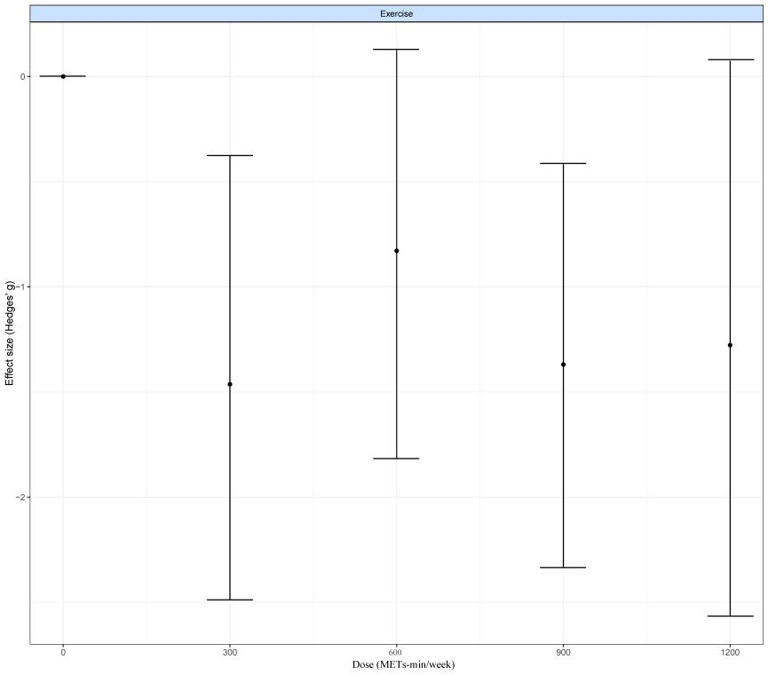
Figure S9. “Split” NMA of overall exercise

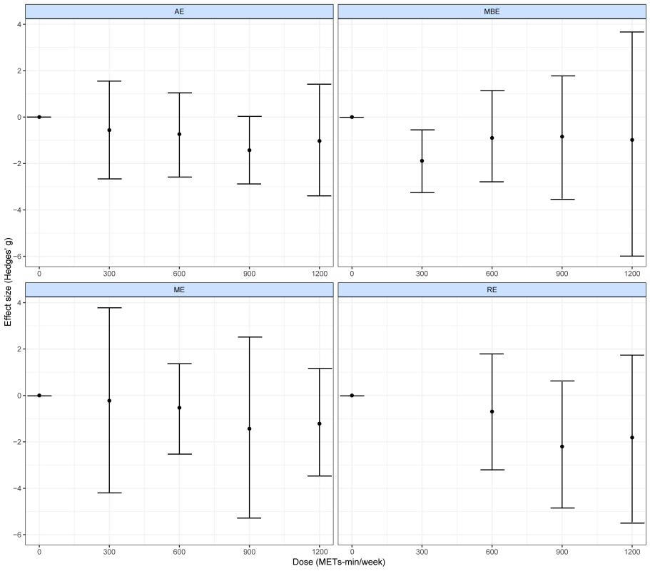
Figure S10. “Split” NMA of different exercise agents. AE, Aerobic exercise; RE, resistance exercise; ME, mix exercise; MBE, mind-body exercise.

S5.4.2 Models selection
For our data, quadratic model shows the best fit and were therefore used in subsequent analyses.
Table S9. Models fit comparison
Model | DIC | SD | Deviance | Residual deviance | pD
Emax (random treatment effects) | 390.2 | NA | 292.19 | 100.28 | 98.8
Restricted cubic spline (common treatment effects; 3 knots) | 1608.9 | NA | 1549.85 | 1357.94 | 59.9
Restricted cubic 10  (random treatment effects; 3 knots) | 391.2 | 1.81  (1.45, 2.25) | 292.04 | 100.13 | 98.5
Non-parametric monotonically up (common treatment effects) | 2133.9 | NA | 2086.89 | 1894.96 | 47.7
Exponential (common treatment effects) | 1644.6 | NA | 1593.91 | 1402.08 | 51.1
Quadratic (random treatment effects) | 369.2 | 1.83  (1.46, 2.28) | 291.73 | 99.8 | 98.6
Note. DIC = Deviance Information Criterion; SD = Between-study Standard Deviation; pD: Number of estimated parameters; NA = Not Applicable. The SD is presented as the main value and (95% Credible Intervals).

In addition to the model fit index, a deviation plot showing the contribution of each data point to the residuals can also help to confirm the robustness of the model selection. The contribution of each data point to the posterior mean bias should be around 1, which indicates a good model fit (53). Deviation plots for overall (Figure S11) and treatment effects (Figure S12) confirm the robustness of our model selection (i.e., deviations <1.5 except for a few data points in the overall exercise and stretch at 300 METs-min, which are all below a contribution of 1.5).
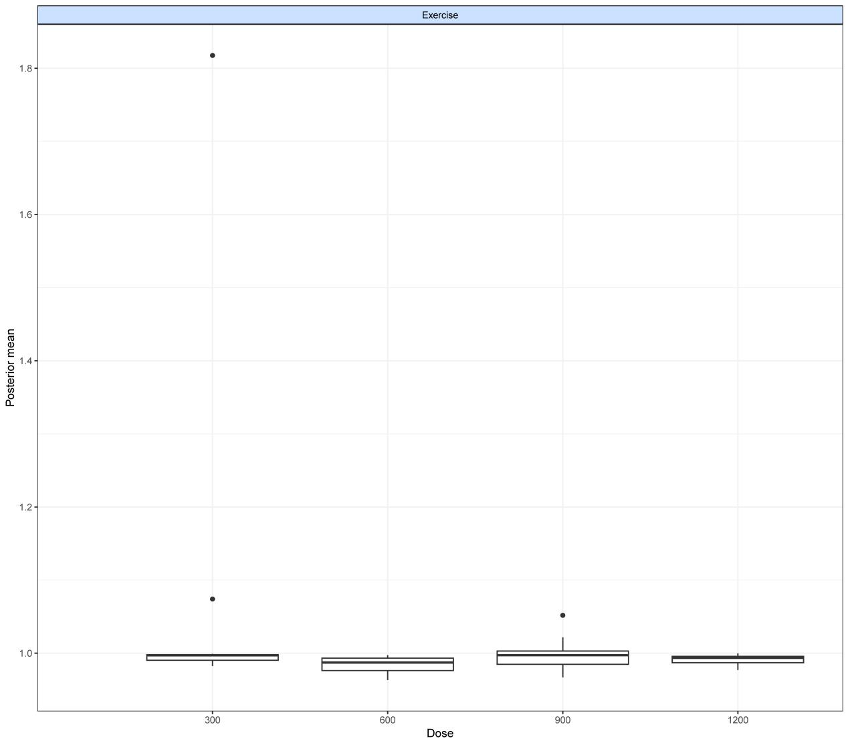
Figure S11. Deviance plot at overall exercise level.
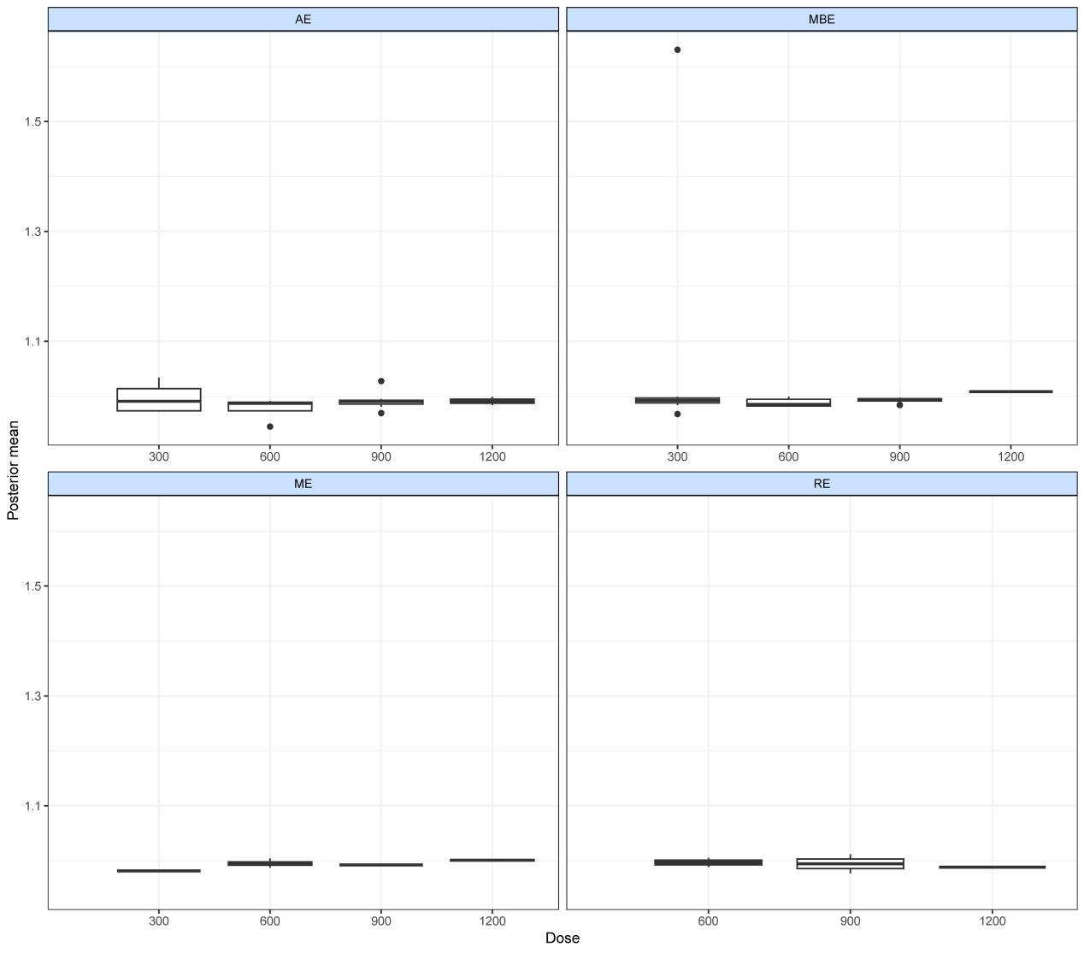
Figure S12. Deviance plots at treatment-level.

5.5 Ranking of effectiveness of interventions
Figure S13 shows the probability of each intervention to be ranked from worst to best (estimated after up to 4000 iterations).
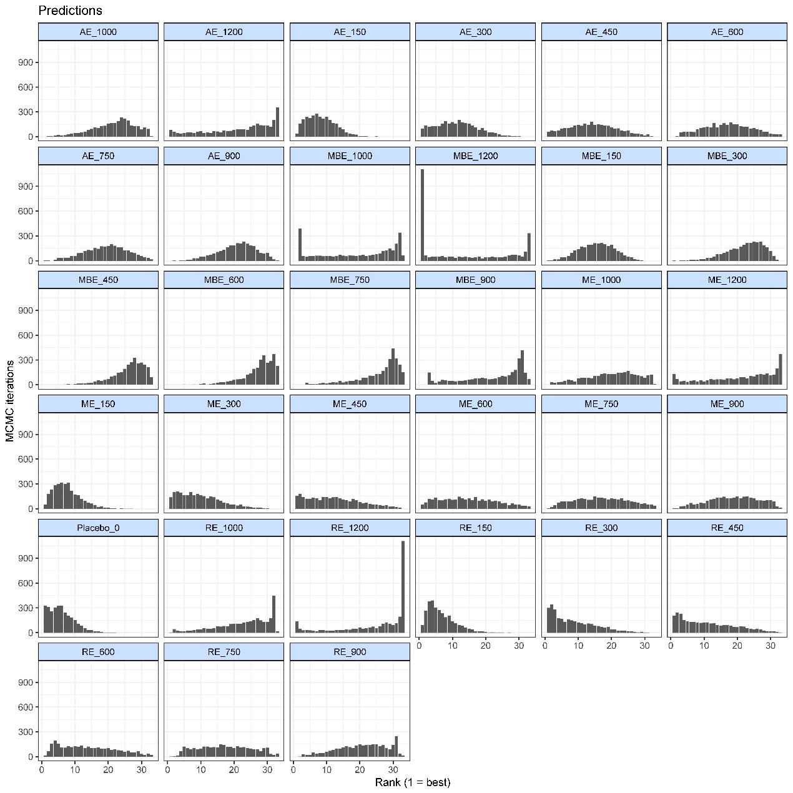
Figure S13. Effectiveness ranking by exercise treatments. The number that follows the exercise intervention indicates the dose of exercise (METs-min/week).

Supplementary file6. PRISMA

PRISMA NMA Checklist of Items to Include When Reporting A Systematic Review Involving a Network Meta-analysis
Section/Topic | Item # | Checklist Item | Reported on Page #
TITLE
Title | 1 | Identify the report as a systematic review incorporating a network meta-analysis (or related form of meta-analysis). | Page. 1  Title page
ABSTRACT
Structured summary | 2 | Provide a structured summary including, as applicable:  Background: main objectives  Methods: data sources; study eligibility criteria, participants, and interventions; study appraisal; and synthesis methods, such as network meta-analysis.  Results: number of studies and participants identified; summary estimates with corresponding confidence/credible intervals; treatment rankings may also be discussed. Authors may choose to summarize pairwise comparisons against a chosen treatment included in their analyses for brevity.  Discussion/Conclusions: limitations; conclusions and implications of findings.  Other: primary source of funding; systematic review registration number with registry name. | Page. 1
INTRODUCTION
Rationale | 3 | Describe the rationale for the review in the context of what is already known, including mention of why a network meta-analysis has been conducted. | Page. 2-4
Objectives | 4 | Provide an explicit statement of questions being addressed, with reference to participants, interventions, comparisons, outcomes, and study design (PICOS). | Page. 2-3
METHODS
Protocol and registration | 5 | Indicate whether a review protocol exists and if and where it can be accessed (e.g., Web address); and, if available, provide registration information, including registration number. | PROSPERO  CRD42023440520
Eligibility criteria | 6 | Specify study characteristics (e.g., PICOS, length of follow-up) and report characteristics (e.g., years considered, language, publication status) used as criteria for eligibility, giving rationale. Clearly describe eligible treatments included in the treatment network, and note whether any have been clustered or merged into the same node (with justification). | Page. 3-4
Information sources | 7 | Describe all information sources (e.g., databases with dates of coverage, contact with study authors to identify additional studies) in the search and date last searched. | Page. 3-4
Search | 8 | Present full electronic search strategy for at least one database, including any limits used, such that it could be repeated. | Supplementary file 1
Study selection | 9 | State the process for selecting studies (i.e., screening, eligibility, included in systematic review, and, if applicable, included in the meta-analysis). | Page. 4
Data collection process | 10 | Describe method of data extraction from reports (e.g., piloted forms, independently, in duplicate) and any processes for obtaining and confirming data from investigators. | Page. 4
Data items | 11 | List and define all variables for which data were sought (e.g., PICOS, funding sources) and any assumptions and simplifications made. | Page. 5
Geometry of the network | S1 | Describe methods used to explore the geometry of the treatment network under study and potential biases related to it. This should include how the evidence base has been graphically summarized for presentation, and what characteristics were compiled and used to describe the evidence base to readers. | Page. 5
Risk of bias within individual studies | 12 | Describe methods used for assessing risk of bias of individual studies (including specification of whether this was done at the study or outcome level), and how this information is to be used in any data synthesis. | Page. 5-6
Summary measures | 13 | State the principal summary measures (e.g., risk ratio, difference in means). Also describe the use of additional summary measures assessed, such as treatment rankings and surface under the cumulative ranking curve (SUCRA) values, as well as modified approaches used to present summary findings from meta-analyses. | Page. 5-6
Planned methods of analysis | 14 | Describe the methods of handling data and combining results of studies for each network meta-analysis. This should include, but not be limited to:  - Handling of multi-arm trials;  - Selection of variance structure;  - Selection of prior distributions in Bayesian analyses; and  - Assessment of model fit. | Page. 6
Assessment of Inconsistency | S2 | Describe the statistical methods used to evaluate the agreement of direct and indirect evidence in the treatment network(s) studied. Describe efforts taken to address its presence when found. | Page. 6
Risk of bias across studies | 15 | Specify any assessment of risk of bias that may affect the cumulative evidence (e.g., publication bias, selective reporting within studies). | Page. 5
Additional analyses | 16 | Describe methods of additional analyses if done, indicating which were pre-specified. This may include, but not be limited to, the following:  - Sensitivity or subgroup analyses;  - Meta-regression analyses;  - Alternative formulations of the treatment network; and  - Use of alternative prior distributions for Bayesian analyses (if applicable). | Page. 6
RESULTS†
Study selection | 17 | Give numbers of studies screened, assessed for eligibility, and included in the review, with reasons for exclusions at each stage, ideally with a flow diagram. | Page.7  Figure 1
Presentation of network structure | S3 | Provide a network graph of the included studies to enable visualization of the geometry of the treatment network. | Figure 2
Summary of network geometry | S4 | Provide a brief overview of characteristics of the treatment network. This may include commentary on the abundance of trials and randomized patients for the different interventions and pairwise comparisons in the network, gaps of evidence in the treatment network, and potential biases reflected by the network structure. | Page.7
Study characteristics | 18 | For each study, present characteristics for which data were extracted (e.g., study size, PICOS, follow-up period) and provide the citations. | Page.7  Supplementary file 2
Risk of bias within studies | 19 | Present data on risk of bias of each study and, if available, any outcome level assessment. | Page.7  Supplementary file 3
Results of individual studies | 20 | For all outcomes considered (benefits or harms), present, for each study: 1) simple summary data for each intervention group, and 2) effect estimates and confidence intervals. Modified approaches may be needed to deal with information from larger networks. | Page.7-8  Supplementary file 4-6
Synthesis of results | 21 | Present results of each meta-analysis done, including confidence/credible intervals. In larger networks, authors may focus on comparisons versus a particular comparator (e.g. placebo or standard care), with full findings presented in an appendix. League tables and forest plots may be considered to summarize pairwise comparisons. If additional summary measures were explored (such as treatment rankings), these should also be presented. | Page. 7-8  Figure. 3, 4, 5  Table. 1, 2  Supplementary file 4-5
Exploration for inconsistency | S5 | Describe results from investigations of inconsistency. This may include such information as measures of model fit to compare consistency and inconsistency models, P values from statistical tests, or summary of inconsistency estimates from different parts of the treatment network. | Supplementary file 5.3
Risk of bias across studies | 22 | Present results of any assessment of risk of bias across studies for the evidence base being studied. | Page.7
Results of additional analyses | 23 | Give results of additional analyses, if done (e.g., sensitivity or subgroup analyses, meta-regression analyses, alternative network geometries studied, alternative choice of prior distributions for Bayesian analyses, and so forth). | Page.8
DISCUSSION
Summary of evidence | 24 | Summarize the main findings, including the strength of evidence for each main outcome; consider their relevance to key groups (e.g., healthcare providers, users, and policy-makers). | Page.9
Limitations | 25 | Discuss limitations at study and outcome level (e.g., risk of bias), and at review level (e.g., incomplete retrieval of identified research, reporting bias). Comment on the validity of the assumptions, such as transitivity and consistency. Comment on any concerns regarding network geometry (e.g., avoidance of certain comparisons). | Page.11
Conclusions | 26 | Provide a general interpretation of the results in the context of other evidence, and implications for future research. | Page. 11
FUNDING
Funding | 27 | Describe sources of funding for the systematic review and other support (e.g., supply of data); role of funders for the systematic review. This should also include information regarding whether funding has been received from manufacturers of treatments in the network and/or whether some of the authors are content experts with professional conflicts of interest that could affect use of treatments in the network. | National Social Science Foundation (2020YFC2006804)

PICOS = population, intervention, comparators, outcomes, study design.
* Text in italics indicateS wording specific to reporting of network meta-analyses that has been added to guidance from the PRISMA statement.
† Authors may wish to plan for use of appendices to present all relevant information in full detail for items in this section.

REFERENCES
1. Bieber M, Görgülü E, Schmidt D, Zabel K, Etyemez S, Friedrichs B, et al. Effects of body-oriented yoga: a RCT study for patients with major depressive disorder. Eur Arch Psychiatry Clin Neurosci. 2021;271(7):1217-29. doi:10.1007/s00406-021-01277-5
2. Blumenthal JA, Babyak MA, Doraiswamy PM, Watkins L, Hoffman BM, Barbour KA, et al. Exercise and pharmacotherapy in the treatment of major depressive disorder. Psychosomatic medicine. 2007;69(7):587-96. doi:10.1097/PSY.0b013e318148c19a
3. Brenes GA, Williamson JD, Messier SP, Rejeski WJ, Pahor M, Ip E, et al. Treatment of minor depression in older adults: a pilot study comparing sertraline and exercise. Aging & mental health. 2007;11(1):61-8. doi:10.1080/13607860600736372
4. Brush CJ, Hajcak G, Bocchine AJ, Ude AA, Muniz KM, Foti D, et al. A randomized trial of aerobic exercise for major depression: examining neural indicators of reward and cognitive control as predictors and treatment targets. Psychological medicine. 2022;52(5):893-903. doi:10.1017/s0033291720002573
5. Chau RMW, Tsui AYY, Wong EYW, Cheung EYY, Chan DYC, Lau PMY, et al. Effectiveness of a structured physical rehabilitation program on the physical fitness, mental health and pain for Chinese patients with major depressive disorders in Hong Kong - a randomized controlled trial with 9-month follow-up outcomes. Disability and rehabilitation. 2022;44(8):1294-304. doi:10.1080/09638288.2020.1800833
6. Chin APMJ, van Poppel MN, Twisk JW, van Mechelen W. Effects of resistance and all-round, functional training on quality of life, vitality and depression of older adults living in long-term care facilities: a 'randomized' controlled trial [ISRCTN87177281]. BMC Geriatr. 2004;4:5. doi:10.1186/1471-2318-4-5
7. Chou KL, Lee PW, Yu EC, Macfarlane D, Cheng YH, Chan SS, et al. Effect of Tai Chi on depressive symptoms amongst Chinese older patients with depressive disorders: a randomized clinical trial. International journal of geriatric psychiatry. 2004;19(11):1105-7. doi:10.1002/gps.1178
8. Danielsson L, Papoulias I, Petersson EL, Carlsson J, Waern M. Exercise or basic body awareness therapy as add-on treatment for major depression: a controlled study. Journal of affective disorders. 2014;168:98-106. doi:10.1016/j.jad.2014.06.049
9. Doose M, Ziegenbein M, Hoos O, Reim D, Stengert W, Hoffer N, et al. Self-selected intensity exercise in the treatment of major depression: A pragmatic RCT. International journal of psychiatry in clinical practice. 2015;19(4):266-75. doi:10.3109/13651501.2015.1082599
10. Doyne EJ, Ossip-Klein DJ, Bowman ED, Osborn KM, McDougall-Wilson IB, Neimeyer RA. Running versus weight lifting in the treatment of depression. Journal of consulting and clinical psychology. 1987;55(5):748-54. doi:10.1037//0022-006x.55.5.748
11. Epstein D. Aerobic activity versus group cognitive therapy: an evaluative study of contrasting interventions for the alleviation of clinical depression: University of Nevada, Reno; 1986.
12. Gao L, Zhang L, Qi H, Petridis L. Middle-aged Female Depression in Perimenopausal Period and Square Dance Intervention. Psychiatria Danubina. 2016;28(4):372-8.
13. Hallgren M, Kraepelien M, Öjehagen A, Lindefors N, Zeebari Z, Kaldo V, et al. Physical exercise and internet-based cognitive-behavioural therapy in the treatment of depression: randomised controlled trial. The British journal of psychiatry : the journal of mental science. 2015;207(3):227-34. doi:10.1192/bjp.bp.114.160101
14. Hanssen H, Minghetti A, Faude O, Schmidt-Trucksäss A, Zahner L, Beck J, et al. Effects of Endurance Exercise Modalities on Arterial Stiffness in Patients Suffering from Unipolar Depression: A Randomized Controlled Trial. Front Psychiatry. 2017;8:311. doi:10.3389/fpsyt.2017.00311
15. Haussleiter IS, Bolsinger B, Assion HJ, Juckel G. Adjuvant Guided Exercise Therapy Versus Self-Organized Activity in Patients With Major Depression. The Journal of nervous and mental disease. 2020;208(12):982-8. doi:10.1097/nmd.0000000000001240
16. Hemat-Far A, Shahsavari A, Mousavi SR. Effects of selected aerobic exercises on the depression and concentrations of plasma serotonin in the depressed female students aged 18 to 25. Journal of Applied Research. 2012;12(1).
17. Huang T-T, Liu C-B, Tsai Y-H, Chin Y-F, Wong C-H. Physical fitness exercise versus cognitive behavior therapy on reducing the depressive symptoms among community-dwelling elderly adults: A randomized controlled trial. International journal of nursing studies. 2015;52(10):1542-52.
18. Imboden C, Gerber M, Beck J, Holsboer-Trachsler E, Pühse U, Hatzinger M. Aerobic exercise or stretching as add-on to inpatient treatment of depression: Similar antidepressant effects on depressive symptoms and larger effects on working memory for aerobic exercise alone. Journal of affective disorders. 2020;276:866-76.
19. Kinser PA, Bourguignon C, Whaley D, Hauenstein E, Taylor AG. Feasibility, acceptability, and effects of gentle hatha yoga for women with major depression: findings from a randomized controlled mixed-methods study. Archives of psychiatric nursing. 2013;27(3):137-47.
20. Kinser PA, Elswick R, Kornstein S. Potential long-term effects of a mind–body intervention for women with major depressive disorder: Sustained mental health improvements with a pilot yoga intervention. Archives of psychiatric nursing. 2014;28(6):377-83.
21. Krogh J, Videbech P, Thomsen C, Gluud C, Nordentoft M. II trial. Aerobic exercise versus stretching exercise in patients with major depression—a randomised clinical trial. PloS one. 2012;7(10):e48316.
22. La Rocque CL, Mazurka R, Stuckless TJ, Pyke K, Harkness KL. Randomized controlled trial of bikram yoga and aerobic exercise for depression in women: Efficacy and stress-based mechanisms. Journal of affective disorders. 2021;280:457-66.
23. Legrand FD. Effects of exercise on physical self-concept, global self-esteem, and depression in women of low socioeconomic status with elevated depressive symptoms. Journal of Sport and Exercise Psychology. 2014;36(4):357-65.
24. Lok N, Lok S, Canbaz M. The effect of physical activity on depressive symptoms and quality of life among elderly nursing home residents: Randomized controlled trial. Archives of gerontology and geriatrics. 2017;70:92-8.
25. Makizako H, Tsutsumimoto K, Doi T, Makino K, Nakakubo S, Liu-Ambrose T, et al. Exercise and horticultural programs for older adults with depressive symptoms and memory problems: a randomized controlled trial. Journal of clinical medicine. 2019;9(1):99.
26. Mather AS, Rodriguez C, Guthrie MF, McHarg AM, Reid IC, McMurdo ME. Effects of exercise on depressive symptoms in older adults with poorly responsive depressive disorder: randomised controlled trial. The British Journal of Psychiatry. 2002;180(5):411-5.
27. Mota-Pereira J, Silverio J, Carvalho S, Ribeiro JC, Fonte D, Ramos J. Moderate exercise improves depression parameters in treatment-resistant patients with major depressive disorder. Journal of psychiatric research. 2011;45(8):1005-11.
28. Nabkasorn C, Miyai N, Sootmongkol A, Junprasert S, Yamamoto H, Arita M, et al. Effects of physical exercise on depression, neuroendocrine stress hormones and physiological fitness in adolescent females with depressive symptoms. The European Journal of Public Health. 2006;16(2):179-84.
29. Oertel-Knöchel V, Mehler P, Thiel C, Steinbrecher K, Malchow B, Tesky V, et al. Effects of aerobic exercise on cognitive performance and individual psychopathology in depressive and schizophrenia patients. European archives of psychiatry and clinical neuroscience. 2014;264:589-604.
30. Pilu A, Sorba M, Hardoy MC, Floris AL, Mannu F, Seruis ML, et al. Efficacy of physical activity in the adjunctive treatment of major depressive disorders: preliminary results. Clinical Practice and Epidemiology in Mental Health. 2007;3:1-4.
31. Pfaff JJ, Alfonso H, Newton RU, Sim M, Flicker L, Almeida OP. ACTIVEDEP: a randomised, controlled trial of a home-based exercise intervention to alleviate depression in middle-aged and older adults. British journal of sports medicine. 2014;48(3):226-32.
32. Prakhinkit S, Suppapitiporn S, Tanaka H, Suksom D. Effects of Buddhism walking meditation on depression, functional fitness, and endothelium-dependent vasodilation in depressed elderly. The journal of alternative and complementary medicine. 2014;20(5):411-6.
33. Prathikanti S, Rivera R, Cochran A, Tungol JG, Fayazmanesh N, Weinmann E. Treating major depression with yoga: A prospective, randomized, controlled pilot trial. Plos one. 2017;12(3):e0173869.
34. Roy A, Govindan R, Muralidharan K. The impact of an add-on video assisted structured aerobic exercise module on mood and somatic symptoms among women with depressive disorders: study from a tertiary care centre in India. Asian Journal of Psychiatry. 2018;32:118-22.
35. Schuver KJ, Lewis BA. Mindfulness-based yoga intervention for women with depression. Complementary therapies in medicine. 2016;26:85-91.
36. Scott TM, Gerbarg PL, Silveri MM, Nielsen GH, Owen L, Nyer M, et al. Psychological function, iyengar yoga, and coherent breathing: a randomized controlled dosing study. Journal of Psychiatric Practice®. 2019;25(6):437-50.
37. Sharma A, Barrett MS, Cucchiara AJ, Gooneratne NS, Thase ME. A breathing-based meditation intervention for patients with major depressive disorder following inadequate response to antidepressants: a randomized pilot study. The Journal of clinical psychiatry. 2017;78(1):493.
38. Singh NA, Clements KM, Fiatarone MA. A randomized controlled trial of progressive resistance training in depressed elders. The Journals of Gerontology Series A: Biological Sciences and Medical Sciences. 1997;52(1):M27-M35.
39. Singh NA, Stavrinos TM, Scarbek Y, Galambos G, Liber C, Fiatarone Singh MA, et al. A randomized controlled trial of high versus low intensity weight training versus general practitioner care for clinical depression in older adults. The Journals of Gerontology Series A: Biological Sciences and Medical Sciences. 2005;60(6):768-76.
40. Streeter CC, Gerbarg PL, Whitfield TH, Owen L, Johnston J, Silveri MM, et al. Treatment of major depressive disorder with Iyengar yoga and coherent breathing: a randomized controlled dosing study. The Journal of Alternative and Complementary Medicine. 2017;23(3):201-7.
41. Streeter CC, Gerbarg PL, Brown RP, Scott TM, Nielsen GH, Owen L, et al. Thalamic gamma aminobutyric acid level changes in major depressive disorder after a 12-week Iyengar yoga and coherent breathing intervention. The Journal of Alternative and Complementary Medicine. 2020;26(3):190-7.
42. Field T, Diego M, Delgado J, Medina L. Tai chi/yoga reduces prenatal depression, anxiety and sleep disturbances. Complementary therapies in clinical practice. 2013;19(1):6-10.
43. Tsang HW, Fung KM, Chan AS, Lee G, Chan F. Effect of a qigong exercise programme on elderly with depression. International Journal of Geriatric Psychiatry: A journal of the psychiatry of late life and allied sciences. 2006;21(9):890-7.
44. Tsang HW, Tsang WW, Jones AY, Fung KM, Chan AH, Chan EP, et al. Psycho-physical and neurophysiological effects of qigong on depressed elders with chronic illness. Aging & mental health. 2013;17(3):336-48.
45. Uebelacker LA, Tremont G, Gillette LT, Epstein-Lubow G, Strong DR, Abrantes AM, et al. Adjunctive yoga v. health education for persistent major depression: a randomized controlled trial. Psychological medicine. 2017;47(12):2130-42.
46. Yeung A, Lepoutre V, Wayne P, Yeh G, Slipp LE, Fava M, et al. Tai chi treatment for depression in Chinese Americans: a pilot study. American Journal of Physical Medicine & Rehabilitation. 2012;91(10):863-70.
47. Wheeler DC, Hickson DA, Waller LA. Assessing Local Model Adequacy in Bayesian Hierarchical Models Using the Partitioned Deviance Information Criterion. Computational statistics & data analysis. 2010;54(6):1657-71. doi:10.1016/j.csda.2010.01.025
48. White IR, Barrett JK, Jackson D, Higgins JP. Consistency and inconsistency in network meta-analysis: model estimation using multivariate meta-regression. Research synthesis methods. 2012;3(2):111-25. doi:10.1002/jrsm.1045
49. Cipriani A, Higgins JP, Geddes JR, Salanti G. Conceptual and tecnical challenges in network meta-analysis. Ann Intern Med. 2013;159(2):130-7. doi:10.7326/0003-4819-159-2-201307160-00008
50. Salanti G, Del Giovane C, Chaimani A, Caldwell DM, Higgins JP. Evaluating the quality of evidence from a network meta-analysis. PloS one. 2014;9(7):e99682. doi:10.1371/journal.pone.0099682
51. van Valkenhoef G, Dias S, Ades AE, Welton NJ. Automated generation of node-splitting models for assessment of inconsistency in network meta-analysis. Research synthesis methods. 2016;7(1):80-93. doi:10.1002/jrsm.1167
52. Mawdsley D, Bennetts M, Dias S, Boucher M, Welton NJ. Model-Based Network Meta-Analysis: A Framework for Evidence Synthesis of Clinical Trial Data. CPT: pharmacometrics & systems pharmacology. 2016;5(8):393-401. doi:10.1002/psp4.12091
53. Dias S, Sutton AJ, Ades AE, Welton NJ. Evidence synthesis for decision making 2: a generalized linear modeling framework for pairwise and network meta-analysis of randomized controlled trials. Medical decision making : an international journal of the Society for Medical Decision Making. 2013;33(5):607-17. doi:10.1177/0272989x12458724

